PCB 4674 Evolution June 1, 2016
Lab # 4: Population Genetics

POPULATION GENETICS
Reference chapters (in textbook): Ch. 6

Lab objectives:
- Explore population genetics assumptions.
- Understand how selection, mutation, migration and drift affect the evolutionary process.
- Come away with an understanding of how beneficial or deleterious recessive alleles may or may not persist in a population depending on the evolutionary forces at work.

Parameter Definitions
Pop. Size: Size of each simulated population.
Initial Frequency of A₁ allele: The proportion of alleles in the population of individuals that are of a particular type when you start the simulation. E.g. originally 50% of alleles are A₁, then the initial frequency of al allele will be p = 0.5. Notice that A₁ is not necessarily dominant – it will depend on its relative fitness values.
# of Populations: Number of different populations to simulate at the same time.
Number of Generations: Number of generations the simulation can run through.
Fitness: Relative fitness of a genotype scaled such that the maximum fitness is 1.0. E.g. If A₂A₂ individuals only have 80% of the fitness that A₁A₁ individuals have, fitness for A₁A₁ will be presented as w_{A1A1} = 1.0, and fitness for A₂A₂ will be w_{A2A2} = 0.8.
Migration Rate (in both Island and Source/Sink models): Number of migrants from source population per generation to your population.
Migration Freq. A₁ (in Source/Sink model): The proportion of A₁ alleles in the source population.
Mutation Rate: The rate at which alleles randomly mutate from either A₁→A₂ or A₂→ A₁.
Bottle Neck: Population undergoes a drastic reduction in size as a result of chance events. “Start” and “End” indicate the starting and ending generation of the event. BN Pop. indicates the population size remained within the bottleneck event.

General Steps for Lab Activity
→ For today’s lab we will be working in pairs and using a computer simulation to explore various population genetics assumptions and to test the theories we’ve been learning about in class.
→ First, go to this webpage (http://www.radford.edu/~rsheehy/Gen_flash/popgen/). After you have accessed the program, take a few minutes to experiment with the various options on the top of the page. This stage should help you design your experiments and determine which tools are available to you (for more information, please see http://www.radford.edu/~rsheehy/Gen_flash/popgen/Popgen_help/help.html). Take your time!
→ Once you have familiarized yourself with the layout, change the parameters and/or modules in order to work through the questions below.

Questions

- NATURAL SELECTION

Consider a simple case of overdominance alone (no other evolutionary forces) using the parameters: Initial frequency of A₁ allele = 0.1, Fitness A₁A₁ = 0.9, A₁A₂ = 1.0, and A₂A₂ = 0.9.

- Why is this a case of overdominance?

This is case of over dominance because A1 will become more common and A2 will become recessive or die off. The heterozygote has higher relative fitness than either homozygote.

- Will allele A₁ get more or less common through time?

It looks as though it will get more common over time to a certain point. It will dominate over other alleles.

- On the figure below, graph your prediction of the frequency of allele A₁ through time. Consider the shape of the curve as you do so (e.g., is the spread or loss of the allele constant? Does the rate of spread or loss of the allele slow down or speed up over time?, etc.)

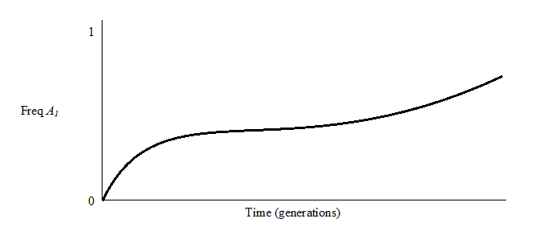
The spread is maintained at some intermediate frequency.

Now, finish setting the following parameters: Pop. Size = 1000, migration and mutation rates = 0, Number of Generations = 100, # of Populations = 5, no migration. Click “Go”.

The dark line on this simulation is the overall trend (assumes infinite population size). The 5 individual color lines are the 5 replicate populations you simulated.

- On the above figure, sketch the results of the simulation. Do your predictions match the results?

It does match my prediction. The A1 frequency becomes more common over generations, but it will stabilize around the 100th generation.

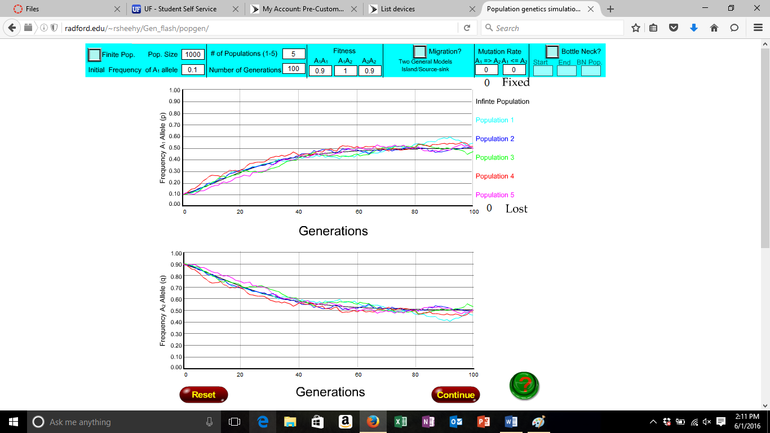

- In the space below, summarize how over dominance alone affects the evolutionary process.

Over dominance will cause genetic drift to slow down because the possible combination of alleles for offspring. This will cause birth defects to be more common, or offspring being prone to certain disease/mental illness/ physical disability. Over dominance alone can maintain genetic diversity in the population (both alleles are maintained at equilibrium).

Now consider a case where allele A₁ is recessive to allele A₂. Set Initial frequency of A₁ allele = 0.5 and Fitness A₂A₂ = 1.0. Leave all other parameters the same as before.

- How do the three fitness values show that allele A₁ is recessive? Is it a beneficial or deleterious allele?

A1A1 has a 0.9 fitness while A2A2 and A1A2 are at 1. It would seem that the A1 allele is recessive since it is not at 1. Allele A1 is a deleterious allele. At the 100th generation it will have up to a 20% frequency, which is relatively low.

- Will allele A₁ get more or less common through time?

A1 will be less common over time to a certain point. The slope of the curve should be negative downward sloping.

- On the figure below, graph your prediction of the frequency of allele A₁ through time. Consider the shape of the curve as you do so (e.g., is the spread or loss of the allele constant? Does the rate of spread or loss of the allele slow down or speed up over time?, etc.)

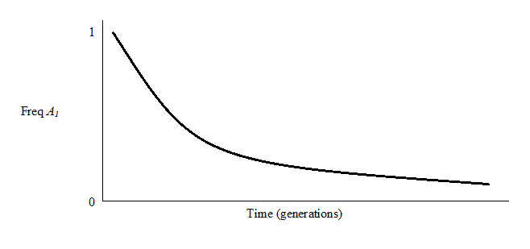
The allele is maintained at a really low frequency but not completely lost.

Make sure p = 0.5, Fitness A₂A₂ = 1.0, and all other parameters are the same as the previous simulation. Click “Go”.

- On the figure above, sketch the results of the simulation. Do your predictions match the results?
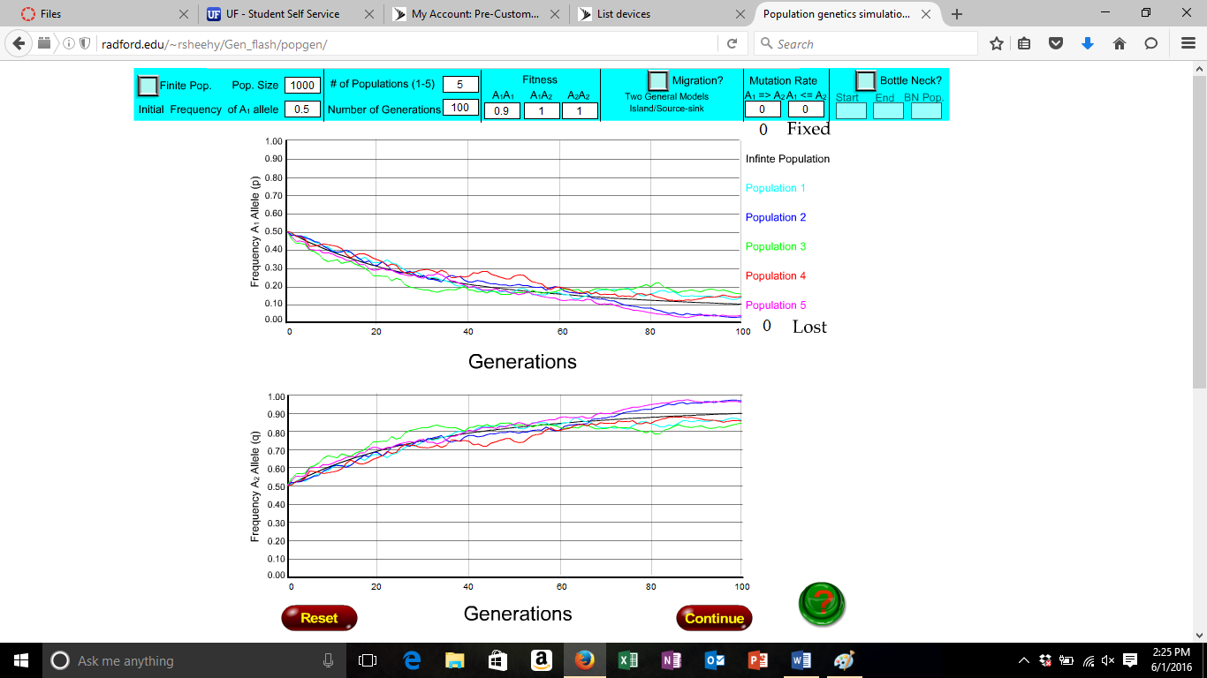

My prediction and the graph are relatively the same.

- Why does recessiveness alone prevent the loss of an allele from a population?

Recessive means that the allele is present, but not expressed. So if there is an allele that is recessive it will continue to be found in future populations.

- How would you increase the strength of selection against allele A₁? Try simulating this situation. How does the strength of selection affect the rate at which the frequency of allele A₁ decreases?
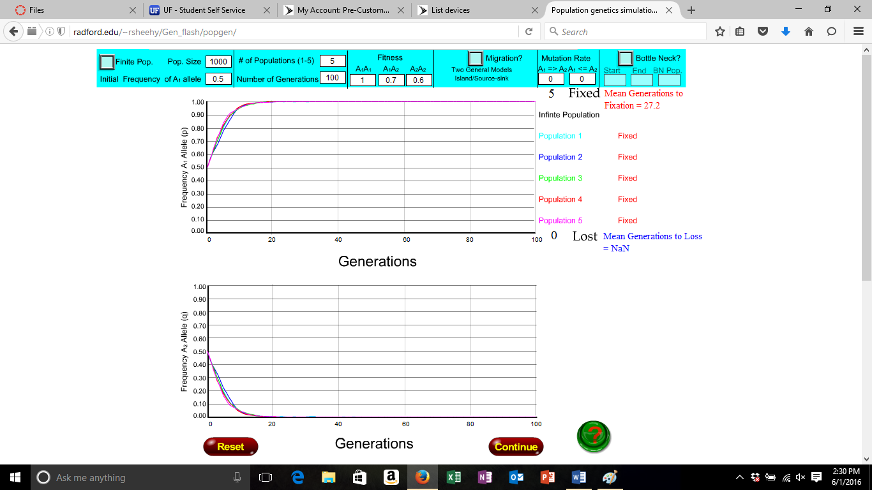

To increase the strength of A1 the fitness levels of A1A2 and A2A2 would have to decrease.

- How could you change the genotype fitness values to make allele A₁ a beneficial recessive allele? Try simulating this situation. Summarize the differences (at least 2) in evolutionary trajectory (i.e., rate of change over time and final endpoint) between a situation where allele A₁ is a beneficial recessive and where allele A₁ is a deleterious recessive.

To make allele A1 a beneficial recessive allele, A1A1 allele would have to be less than 1 and A1A2 and A2A2 would have to be at 1. Complete recessiveness of an allele alone stops the loss of that allele due to variety alone. Because the heterozygote's relative fitness is equal to the homozygote with both beneficial alleles, the deleterious allele is held in the population. The deleterious allele would be considered “hidden”.
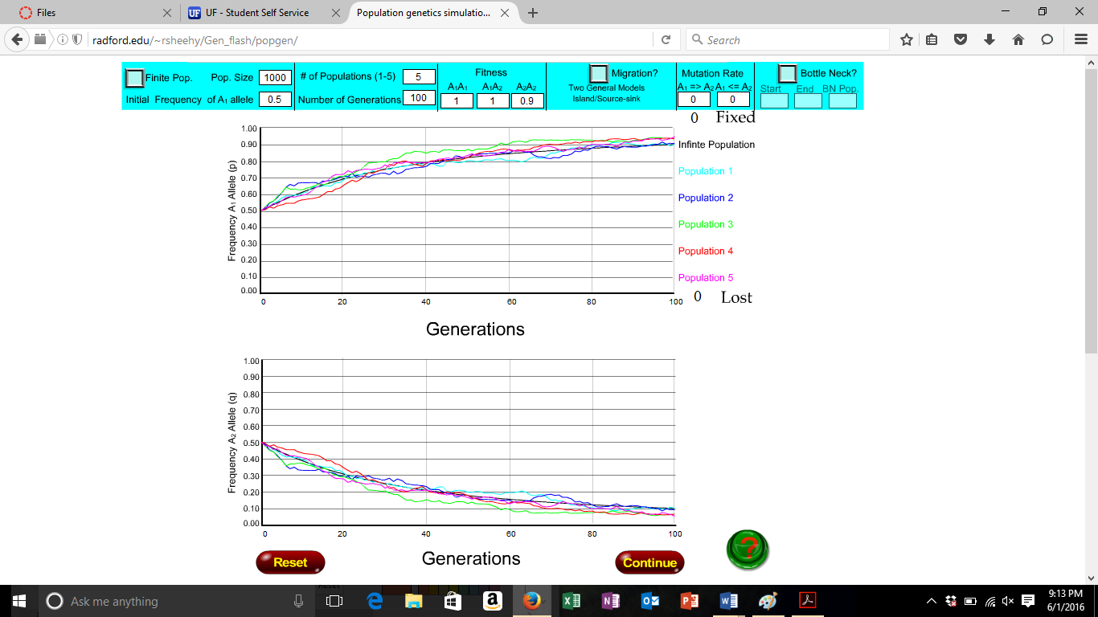

This graph shows A1 as a recessive allele that is deleterious recessive. It is deleterious because as A1 allele frequency increase, A2 is decreasing.

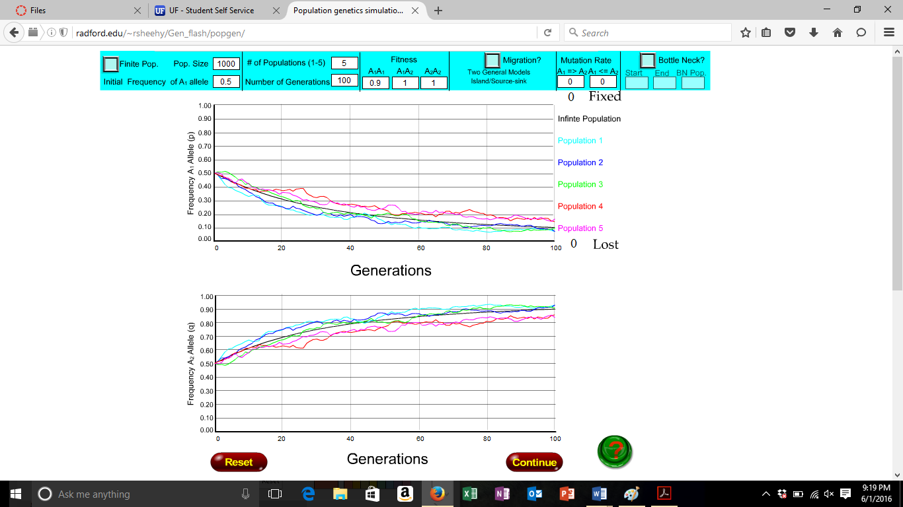

This graph shows that A1 is a beneficial recessive; when A1 is decreasing, A2 is increasing until it becomes stable.

- MUTATION

Consider a simple case of mutation alone. Things would happen extremely slowly if we used realistic mutation rates, so let’s pretend our study population is at Love Canal, Chernobyl, or Three Mile Island. Set Mutation Rate A₁=>A₂ = 0.1, A₂=>A₁ = 0.01, Initial Frequency of allele A₁ = 0, Fitness A₁A₁=A₁A₂=A₂A₂=1. Leave all other parameters the same as in the previous simulation.

- Is mutation from allele A₁ to allele A₂ deleterious, beneficial or neutral? Is mutation from allele A₂ to allele A₁ deleterious, beneficial or neutral?
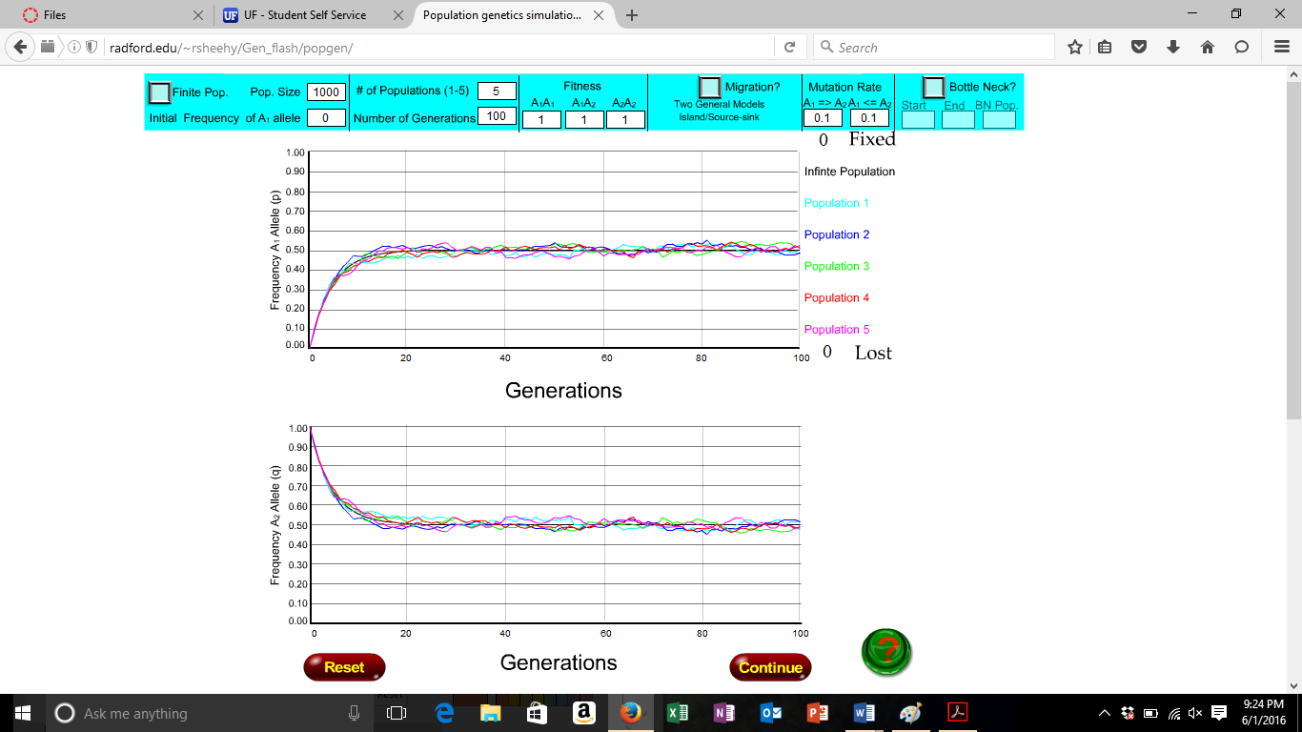

From A1 to A2 the mutation is deleterious because as the allele A1 is increasing the frequency of A2 is decreasing until it becomes stable. From A2 to A1 the mutation is A2 is decreasing while A1 is increasing, I could reason it is a beneficial mutation.

- Will allele A₁ get more or less common through time?

It looks as though A1 would become more common over time since A2 allele is decreasing.

- On the figure below, graph your prediction of the frequency of allele A₁ through time. Consider the shape of the curve as you do so (e.g., Is the spread or loss of the allele constant? Does the rate of spread or loss of the allele slow down or speed up over time?, etc.)

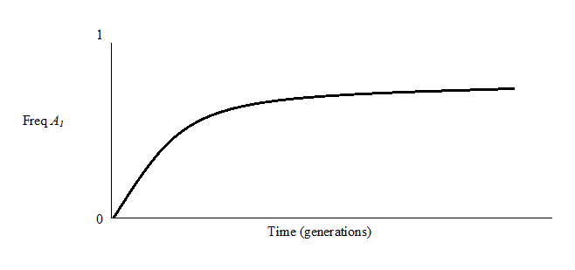

Make sure all parameter values are set as described above. Click “Go”.

- On the figure above, sketch the results of the simulation. Do your predictions match the results?

The graphs for A1 allele are similar.

- Summarize how mutation alone affects the spread or loss of an allele in the population.

Mutation is a random change in a DNA structure. Mutation alone affects the spread or loss of an allele in a population because mutations can complete delete, add and replace certain parts of the DNA. After time, populations could have the allele totally gone, or always expressed.

- Try some more simulations with lower (more realistic) mutation rates. For example, try Mutation Rate A₁=>A₂ = 0.01 and A₂=>A₁ = 0.001. How do decreased mutation rates affect the time it takes for an allele to reach an intermediate frequency?
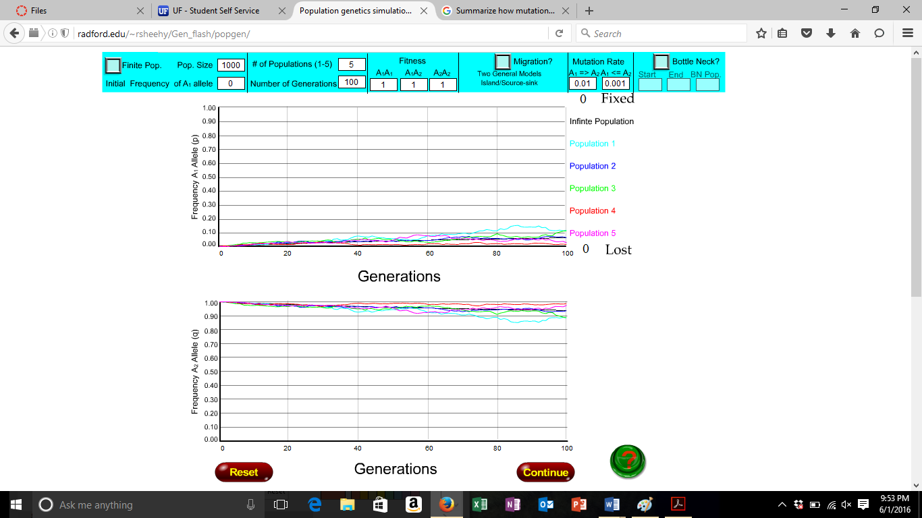
It takes longer for an allele to reach an intermediate frequency when the mutation rates are more realistic.

- NATURAL SELECTION AND MUTATION

Compare the results of the mutation simulations to the selection simulations. Note that mutation alone is a very weak evolutionary force relative to natural selection. Still, mutation is an extremely important evolutionary force. The next two examples will illustrate the effects of mutation when combined with selection on the evolutionary process.

CASE I: Consider a case of mutation-selection balance and the loss of deleterious recessive alleles. Set Initial Frequency of allele A₁ = 0.5, Fitness A₁A₁=1, A₁A₂=1, A₂A₂=0.5, Mutation Rate A₁=>A₂ = 0.001 and A₂=>A₁ = 0. Leave all other parameters the same as in the previous simulation.

- On the figure below, graph your prediction of the frequency of allele A₁ through time. Consider the shape of the curve as you do so (e.g., Is the spread or loss of the allele constant? Does the rate of spread or loss of the allele slow down or speed up over time?, etc.)

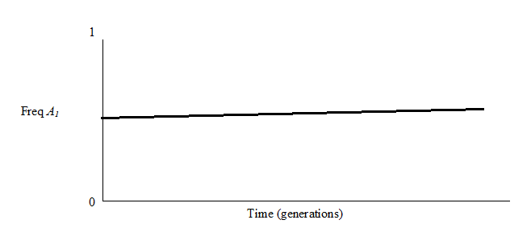

Make sure all parameter values are set as described above. Click “Go”.

- On the figure above, sketch the results of the simulation. Do your predictions match the results?

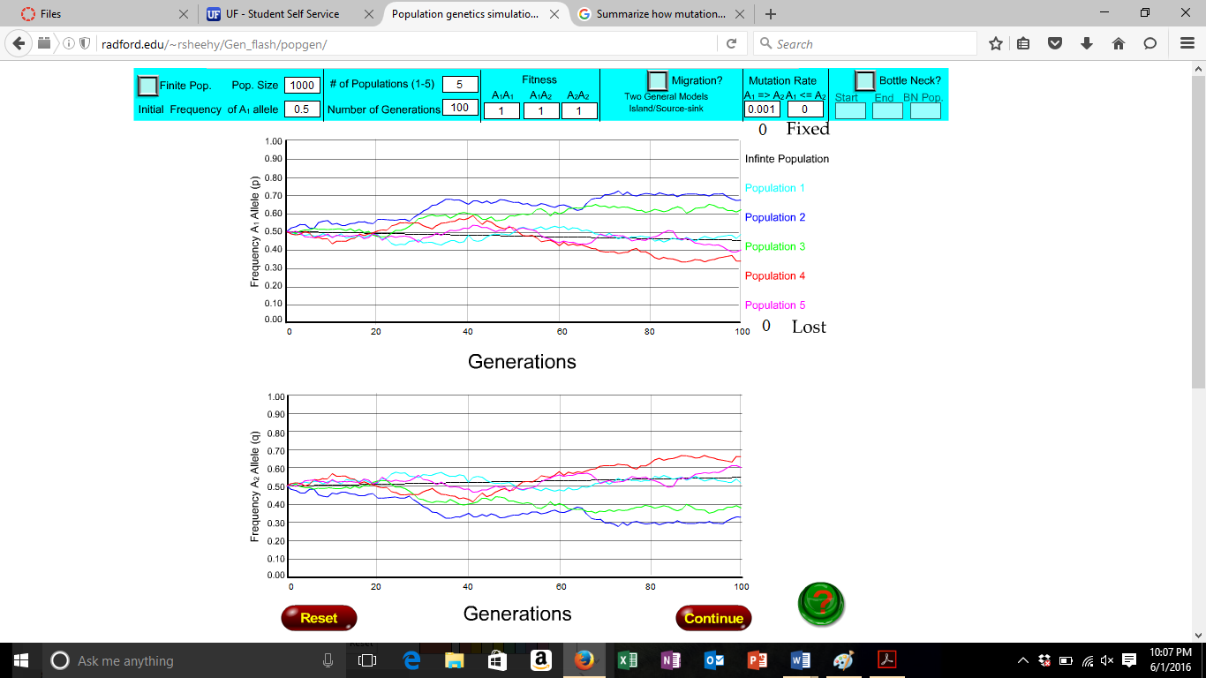

There are two possible reasons why allele A₁ was not fixed in this population (note: these are not mutually exclusive). First, mutation from A₁=>A₂ may be recreating allele A₂ faster than selection takes it out. Second, allele A₂ is “completely recessive”. This means that heterozygotes do not suffer a fitness cost because they have one copy of allele A₂. The next two simulations will test two hypotheses for the maintenance of allele A₂ in this population.

Hypothesis I: Mutation prevents the rapid fixation of allele A₁

- Set the mutation rates to zero, leaving all other parameters the same. Re-run the simulation and compare your results to the previous simulation (with mutation rate A₁ => A₂ = 0.001). Does mutation alone explain the maintenance of allele a in the population?
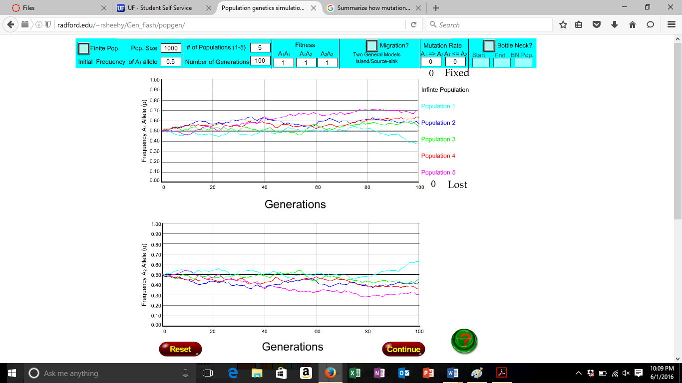
Mutation has some influence but not does totally contribute to the maintanence of Allele A1. Removing the mutations only makes A1 slightly more frequent.

Hypothesis II: Allele A₁ is not fixed in the population because allele A₂ is completely recessive

- Leaving the mutation rates at zero, change Fitness A₁A₂ to 0.9. This makes allele A₂ “partially dominant”, meaning that one copy of allele A₂ has a small deleterious effect on the heterozygote. Re-run the simulation and compare your results to the above two simulations. Does the “complete recessiveness” of allele A2 alone explain the maintenance of allele a in the population?
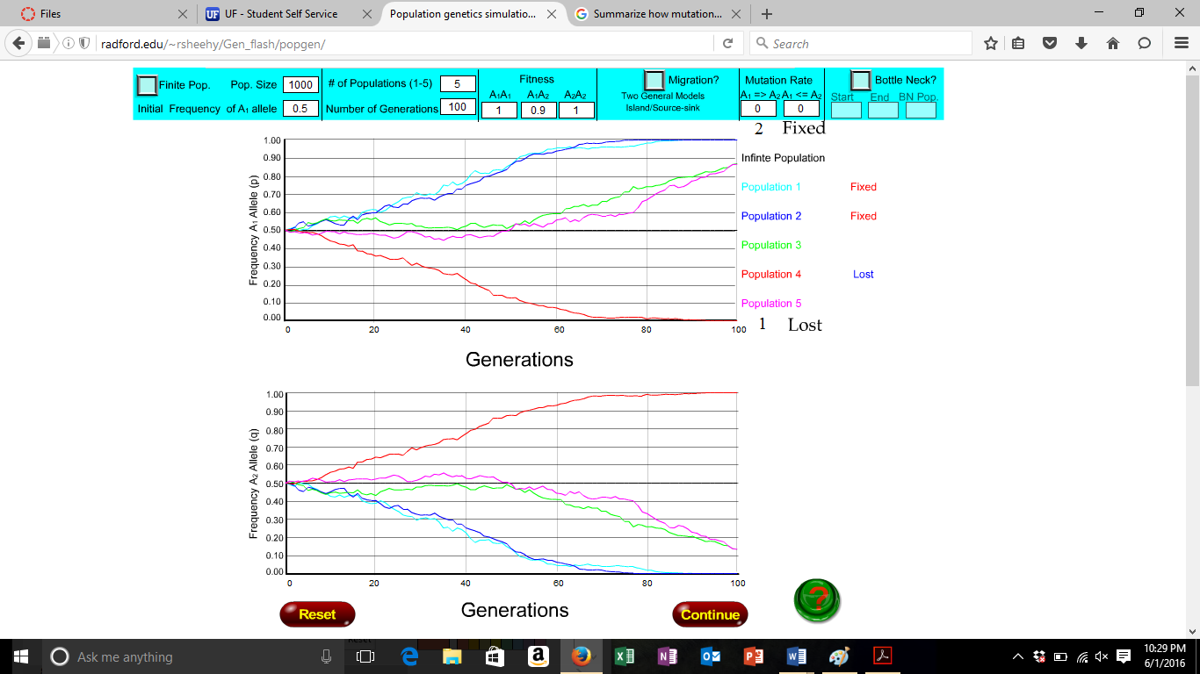

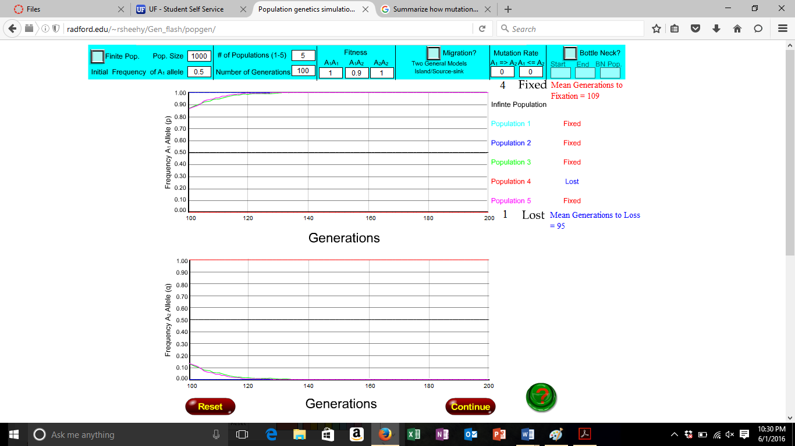

I do think that the recessesiveness of A2 does allow for the frequency of A1 to increase. As A2 allele decreases, A1 allele frequencies increase.

- In terms of evolutionary dynamics, what is the difference between a “completely recessive” allele and a “partially dominant” allele?

A completely recessive allele can be maintained in the population because it is "hidden from selection". Completely recessive alleles do not incur a relative fitness cost because it has one copy of the allele. A partially dominant allele is not "hidden from selection. Because the heterozygote does incur a relative fitness cost, the allele could be removed from the population.

To understand the importance of mutation, reset the Mutation Rates to A₁=>A₂ = 0.001 and A₂=>A₁ = 0. Leave all other parameters the same (allele A₂ is still “partially dominant”). Re-run the simulation.

- Compare these results to the prior situation of “partial dominance” and no mutation. How does mutation affect the evolutionary dynamics?

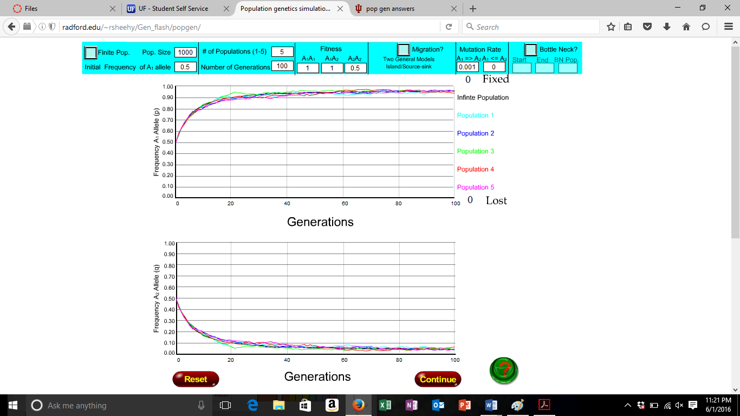

The mutation allows for A1 and A2 to remain in the populations for longer generations.

- Try to re-run several simulations altering the Mutation Rate A₁=>A₂ as you wish. Can mutation alone always prevent the rapid fixation of allele A₁?

Allele A1 is not rapidly fixed. However, at the equilibrium point it is closer to a frequency of 1 than before.

CASE II: Consider another case of mutation-selection balance and the spread of beneficial recessive alleles. Set the following parameters: Initial Frequency of allele A₁ = 1.0, Fitness A₁A₁=0.5, A₁A₂=0.5, A₂A₂=1.0, Mutation Rate A₁=>A₂ = 0.0001, A₂=>A₁ = 0, Number of Generations=1000, Pop. Size=1000, # of Populations=5, and no migration.

- How do the fitness values show that allele A₂ is a beneficial recessive?

It shows that A2 is a beneficial recessive because the fitness values when A2 is with A1 is 0.5 fitness while A2A2 is at 1. This means that the fitness of A2 will always be present in future generations. The beneficial recessive allele gets to fixation more quickly in the population. Mutation is still the only force that can introduce allele A1.

- Will allele A1 get more or less common through time?

It will become less common.

- On the figure below, graph your prediction of the frequency of allele A through time. Consider the shape of the curve as you do so (e.g., Is the spread or loss of the allele constant? Does the rate of spread or loss of the allele slow down or speed up over time?, etc.)
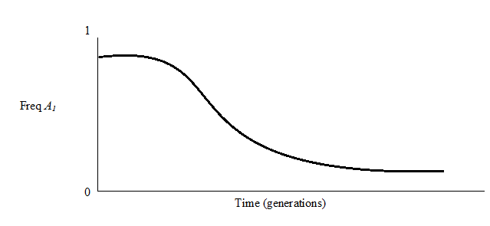

Make sure all parameter values are set as described above. Click “Go”.

- On the figure above, sketch the results of the simulation. Do your predictions match the results?

Yes, they match the results. It should be stable then decline in allele frequency.

- Why does it take allele a so long to make it into the population even though it is an extremely beneficial allele?

The population starts fixed for A1. Mutation is the only force that can introduce A1 into the population. Once A1 is present, it must be in the homozygous state for selection to be fixated.

Now, set Fitness A₁A₂ = 0.6. This makes allele a “partially dominant” because one copy of allele A₂ has a small beneficial effect on the heterozygote. All other parameters remain the same. Re-run the simulation.

- What is the effect of “partial dominance” compared to ‘complete recessiveness” on the evolutionary dynamics when a beneficial recessive allele is considered? (how is this simulation different from the previous one)

The beneficial recessive allele spreads to fixation quicker in a population. Mutation is still the only force that can introduce A1. However, because allele a is partially dominant, selection will begin to drive this allele to fixation.

Three important things to notice from these mutation – selection exercises.
- Mutation can counter-balance selection. Equilibrium allele frequencies may change depending on the mutation rate and the strength of selection (Case I).
- Mutation provides the raw genetic variation that selection can act on (Case II).
- The degree to which an allele is dominant or recessive in a population (from completely dominant to completely recessive and everything in between) affects evolutionary dynamics. The ‘effectiveness’ of selection in eliminating or fixing alleles in a population depends not only on the strength of selection but also on how alleles are expressed in the heterozygote (degree of dominance)

- MIGRATION

Migration tends to homogenize allele frequencies between two populations. Consider the following situation that we will use for comparison when migration is introduced. Set Initial Frequency of allele A₁ = 0.5, Fitness A₁A₁=0.8, A₁A₂=0.8, A₂A₂=1.0, Mutation Rate(s)=0, Number of Generations=100, Pop. Size=1000, # of Populations=5. No migration yet.

- On the figure below, graph your prediction of the frequency of allele A₁ through time. Consider the shape of the curve as you do so (e.g., Is the spread or loss of the allele constant? Does the rate of spread or loss of the allele slow down or speed up over time?, etc.)

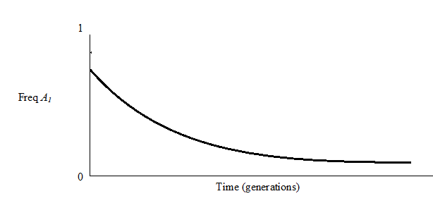

Make sure all parameter values are set as described above. Click “Go”.

- On the figure above, sketch the results of the simulation. Do your predictions match the results?

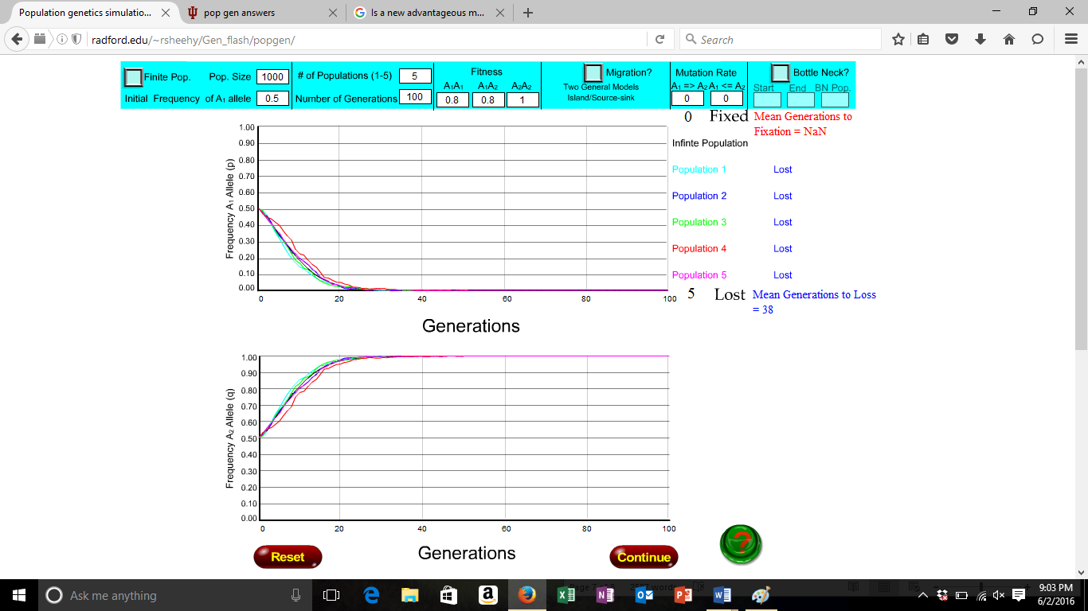

Now let’s introduce a small amount of migration. Suppose there are only A₁A₁ genotypes on the mainland near our island and every 20 generations a migrant arrives. Select “Source-Sink” mode for Migration, set Freq. A₁ = 1.0 and Rate=0.05.

- On the figure below, graph your prediction of the frequency of allele A₁ through time. Consider the shape of the curve as you do so (e.g., Is the spread or loss of the allele constant? Does the rate of spread or loss of the allele slow down or speed up over time?, etc.)
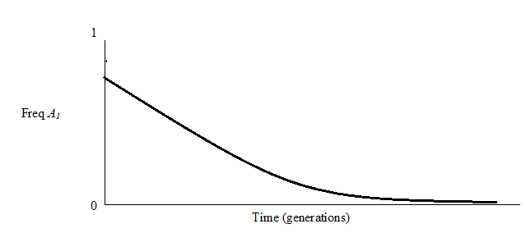

Make sure all parameter values are set as described above. Click “Go”.

- On the figure above, sketch the results of the simulation. Do your predictions match the results?
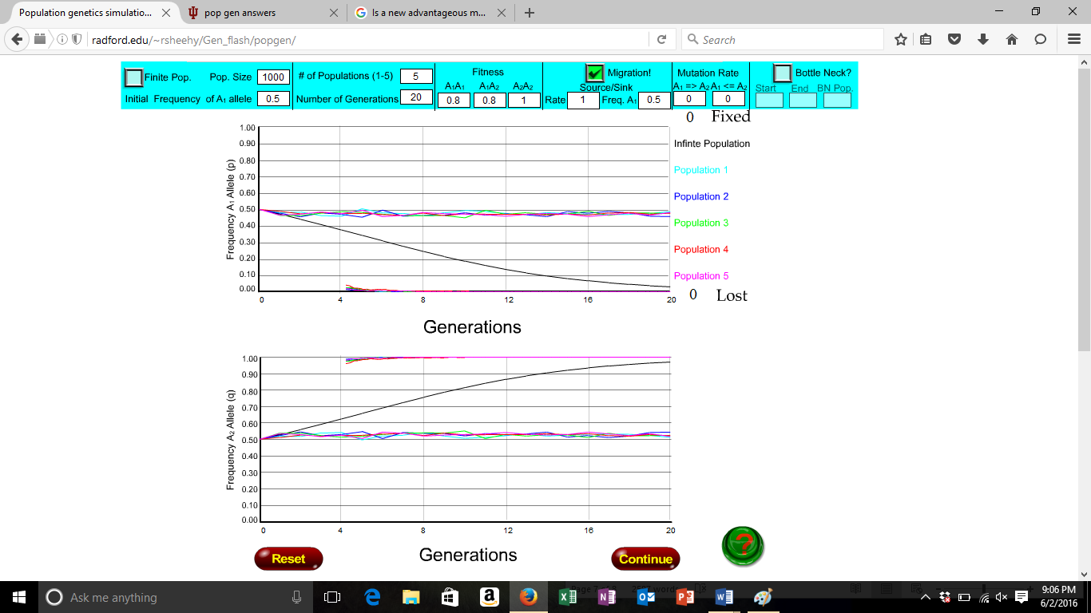

Yes, the predictions are similar.

- Compare the results of this simulation with the previous one. What was the effect of migration on the evolutionary process?

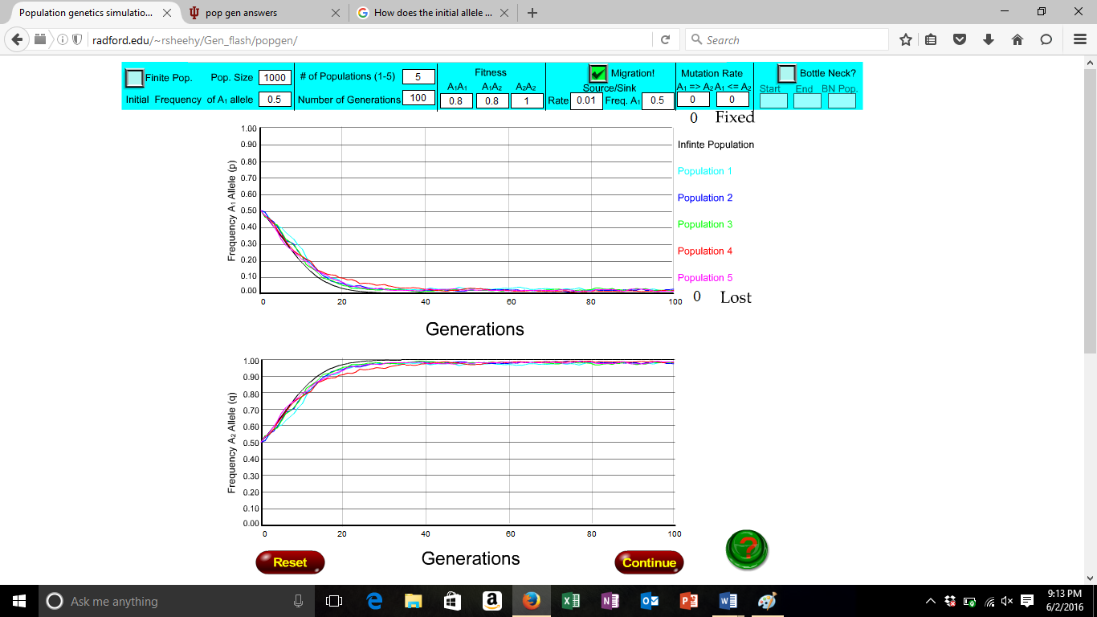

In #36 allele A1 will decline in frequency around generation 30, while in #35 continues show up in generations but slightly declines. In #36 A2 grows and shows in every generation for 100 generations. In #35 A2 also increases toward 1.

Now reduce the migration rate to Rate = 0.01 (one migrant every 100 generations). Re-run the simulation leaving all other parameters the same as before.

- How are the results of this simulation different from the previous two?

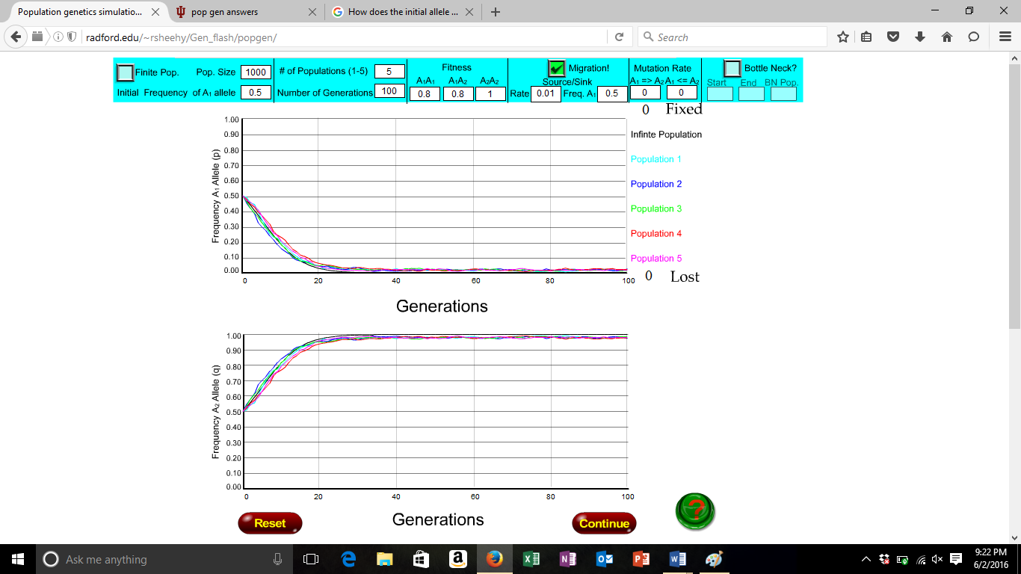

In this simulation, A1 declines in frequency quicker than in #36. I wouldn’t compare A1 #37 to #35 because A1 continues to pursue past 20 generations near 0.5. A2 in #37 reaches 1.0 frequency at the 20th generation. A2 in #36 reaches 1.0 frequency before the 20th generation. In #35 A2 continues throughout the generations on 0.5.

- In terms of effects on allele frequencies in the focal population (our island), the effects of migration are analogous to what other evolutionary force?

The effects of migration are analogous to island biogeography.

- Of the evolutionary forces covered to this point, which are creative (create genetic variation in a population) and which are destructive (reduce genetic variation in a population)? Remember genetic variation refers to allelic variation at a single locus at the population level.

Some evolutionary forces that are creative could be mutations and immigration. Some evolutionary forces that are destructive are bottle neck effect and genetic drift.

- GENETIC DRIFT

You’ve probably noticed by now that the 5 color lines (each representing one of the 5 simulated populations) do not always follow the same path. This is because of genetic drift. Set Initial Frequency of allele A₁ = 0.5, Fitness A₁A₁=A₁A₂=A₂A₂=1.0, Mutation Rate(s)=0, no migration, Number of Generations=100, # of Populations=5.

- Predict what will happen if the population size = 1000 (will allele frequencies change from their initial values).
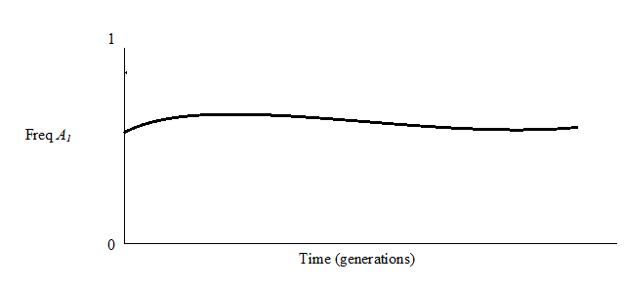

- Run the simulation and explain why the dark line remains at p = 0.5 throughout the simulation and the five color lines ‘wiggle’ around the dark line.
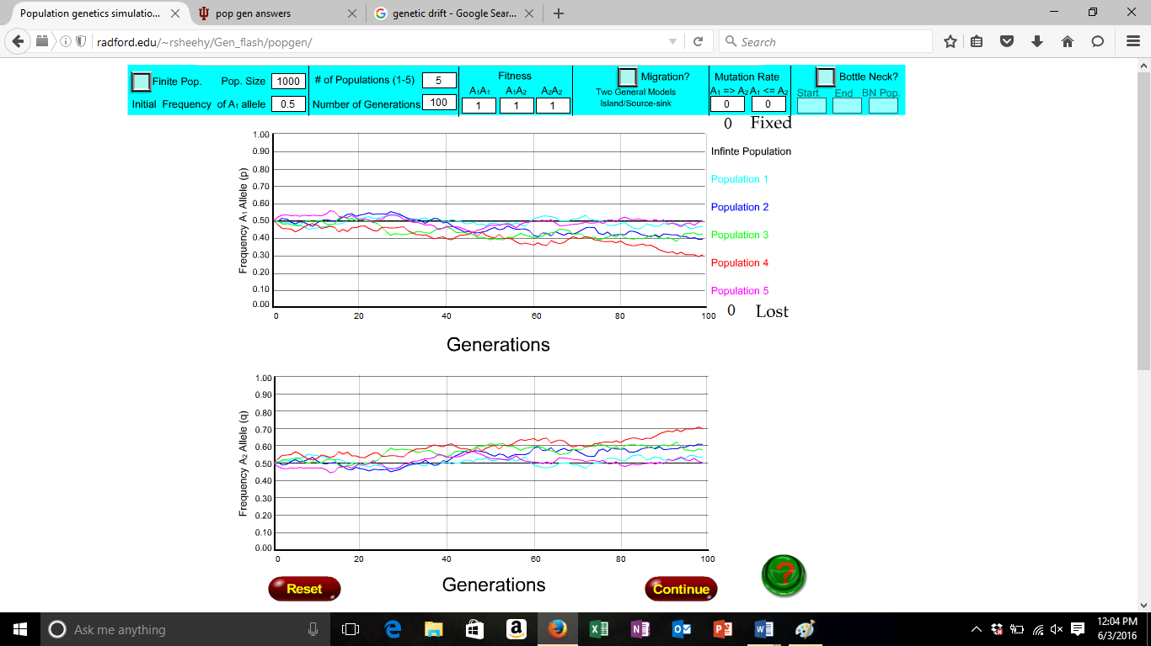

The dark run remains at 0.5 because the frequency A1 is at 0.5. The five color lines are dancing around the dark line because the fitness of each A1A1, A1A2, and A2A2 is 1 so the alleles should be present in all of the populations. The dark line assumes an infinite population size. The other lines are subject to genetic drift.

- Now, we’ll reduce the population size by 1/2 over the course of 5 more simulations (500, 250, 125, 64, 32). Notice how in each of the simulations the dark line (infinite population size) remains steady on p = 0.5. When the population sizes get smaller the frequency of allele A₁ goes to either 0 or 1 in the five colored, single-population lines. Is the rate of fixation or loss of allele A related to population size?

The rate of fixation of allele A1 is not related to population size. It is related to the fitness of the alleles. The lighter lines should diverge more from 0.5 and behave more randomly as the population size reduces.

- Is genetic drift a creative force (creates genetic variation) or a destructive force (reduces genetic variation) within a population?

Genetic drift is a destructive force. “Variation in the relative frequency of different genotypes in a small population, owing to the chance disappearance of particular genes as individuals die or do not reproduce.”

Next, we’ll look at the effect of population size on the spread of a beneficial, “completely recessive” allele in the population. Set Fitness A₁A₁ = 1.0, A₁A₂ = 0.9, A₂A₂ = 0.9 and Initial Frequency of allele A₁= 0.3. Leave all other parameters as before.

- Set the population size = 1000. Roughly how long does it take allele A₁ to fix in the population?

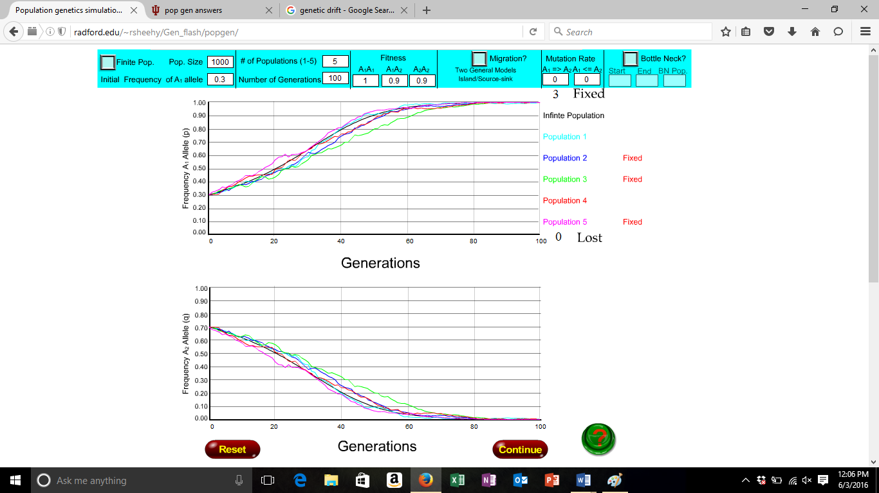

Allele A1 stabilizes around generation 40.

- Reduce the population size to 400, 80, 40 and 20 over the course of 4 more simulations. Compared to the previous simulation, what effect does reducing population size have on the spread of allele A₁ in the population?
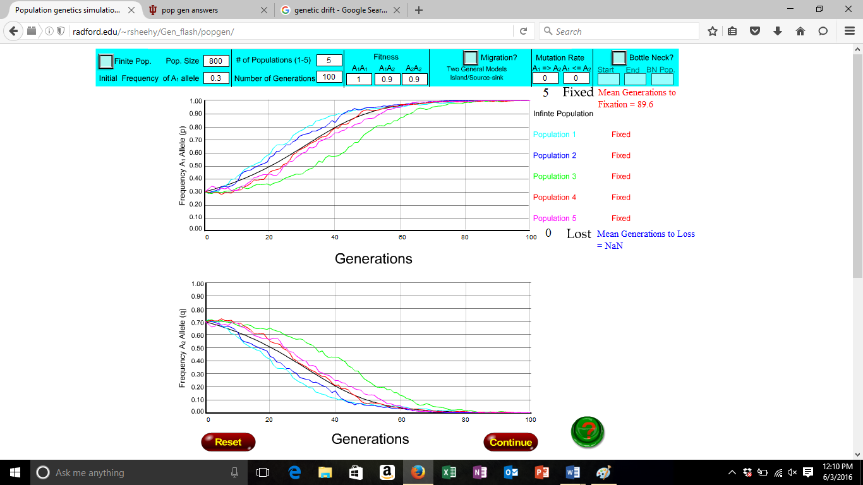
If the population size reduces, then the allele A1 takes longer to stabilize.

- Now run the same simulation 10 times with a population size of 20. Why doesn’t allele A₁ always get fixed?

It doesn’t always get fixed because in population sizes that are low, the frequency can become dominant or recessive very quickly. There is no effect on the dark like but the color lines appear more random. Genetic drift is a lot stronger than selection.

- Now make allele A₁ “partially dominant” (e.g., set Fitness A₁A₂ = 0.95) and re-run the same simulation 10 times with a population size of 20 and compare the results to the previous simulation. How does changing the degree of dominance affect the spread of allele A₁ in the population?

Increasing the degree of dominance of allele A1 increases, the likelihood that it will be fixed. Notice that drift can still be stronger than other selections.

Take-Home Assignment

- This assignment is due next week’s lab time.

1. How does the initial allele frequency affect the rate of loss of a deleterious allele if it is a) dominant versus b) recessive? How might this explain the fact that most genetic diseases are recessive?

Beneficial recessives increase in frequency; deleterious recessives decrease in frequency. Beneficial recessives go to fixation and deleterious recessives are not lost because of selection alone. This explains that diseases could be expressed because of DNA recombination in child development.

2. Is a new advantageous mutant allele more likely to become fixed in a population if it is dominant or recessive?

An advantageous mutant allele is more likely to become fixed in a population if it is a dominant allele.

3. Explain why heterozygote advantage will maintain genetic diversity within a population while heterozygote disadvantage can maintain diversity among populations.

Heterozygote advantage will maintain genetic diversity with a population because it has a higher relative fitness. Heterozygous disadvantage cannot maintain diversity because it has lower relative fitness.

4. In the absence of selection, how is the magnitude of genetic drift affected by population size?

In small populations genetic drift is quick. In large population genetic drift is slow.

5. How does population size affect the effectiveness of selection?

A small population size would allow selection to happen slow, and a large population size would allow it to happen quickly.

6. Mutation is an evolutionary force. How does the strength vary with population size? What might this mean for the arms race between humans and their pathogens?

The strength of mutation varies with population size. If a population size is low, the rate of mutation is high. If the population is large then the rate of mutation is lower.

